**Status Report – Layout changes – coming issue**

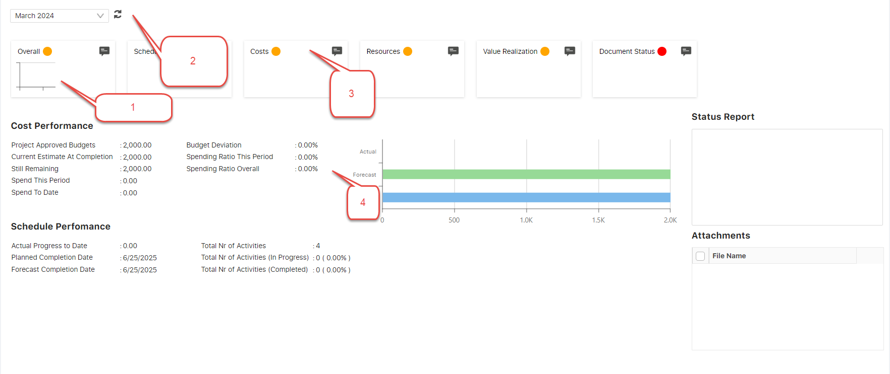

1. How to manage – chart **shift to other section**.
2. If data blank - right section **chart** not coming how to manage.
3. All card coming in DevExpress grid – how to manage this card in **slider**.
4. This data and chart coming one UC - how to position shift to **right section**.

